**Contents**

**S.No TITLE**

1. **Introduction**

**1.1 Overview**

**1.2 Purpose**

1. **Result**
2. **Disadvantage**
3. **Application**
4. **Conclusion**
5. **Future Scope**

**Introduction**

* 1. **Overview**

**In the present world, the major components of any transportation system include**

**passenger airline, cargo airline, and air traffic control system. With the passage of**

**time, nations around the world have tried to evolve numerous techniques of improving**

**the airline transportation system. This has brought drastic change in the airline**

**operations. Flight delays occasionally cause inconvenience to the modern passengers**

**[1]. Every year approximately 20% of airline flights are canceled or delayed, costing**

**passengers more than 20 billion dollars in money and their time.**

* 1. **Purpose**

**The airline will either delay the flight to give the mechanics plenty of time to fix the problem, or they will change planes entirely. There are plenty of other reasons why passengers face flight delays, such as time for fueling, boarding passengers, aircraft cleaning, etc.**

**Result**

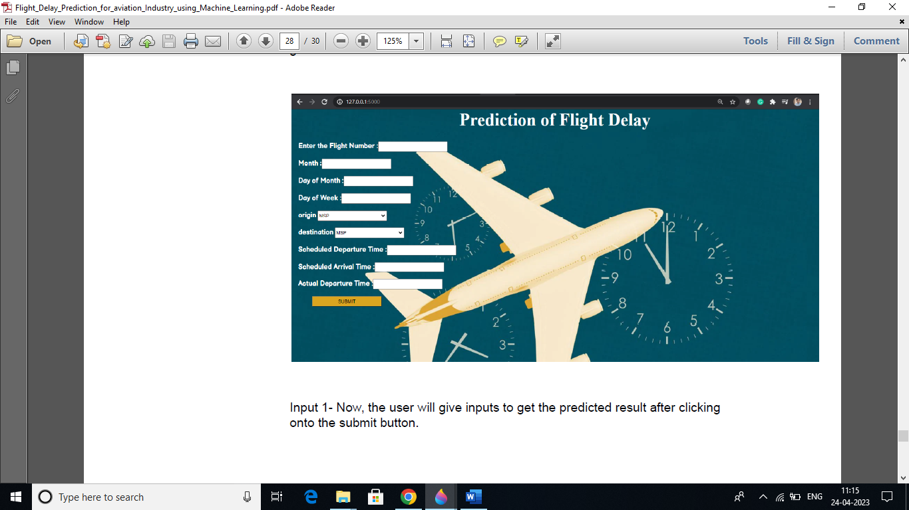

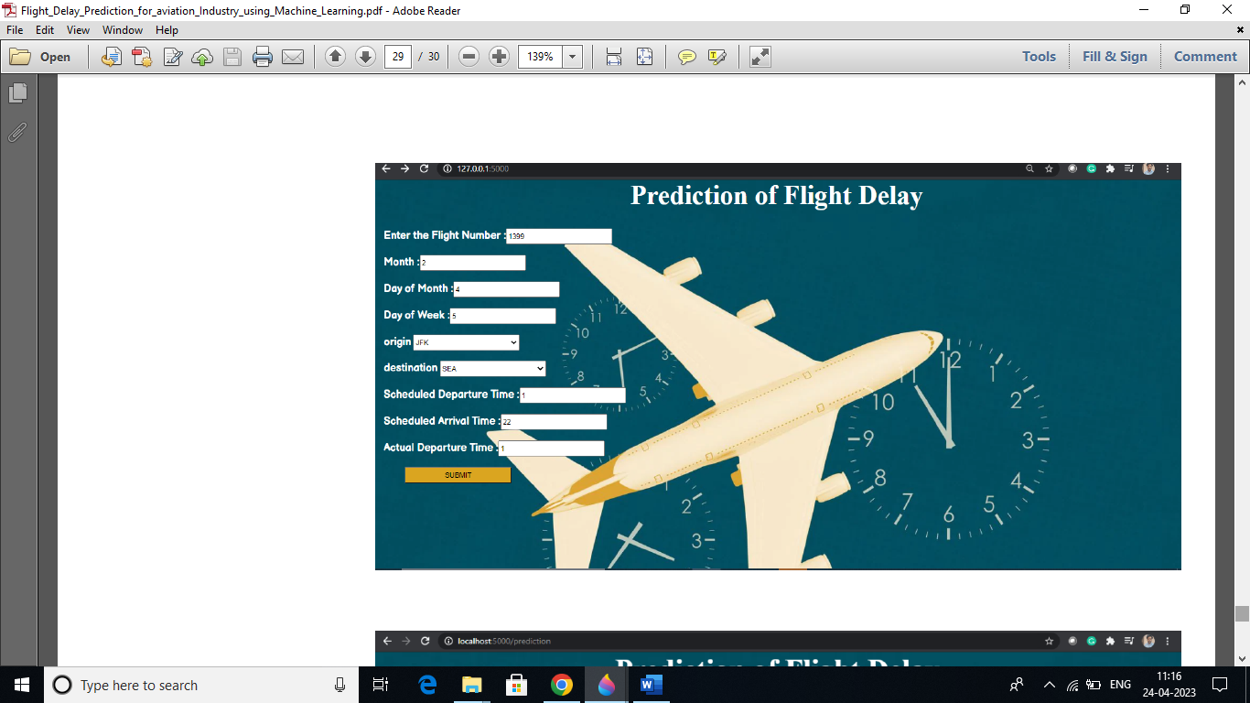

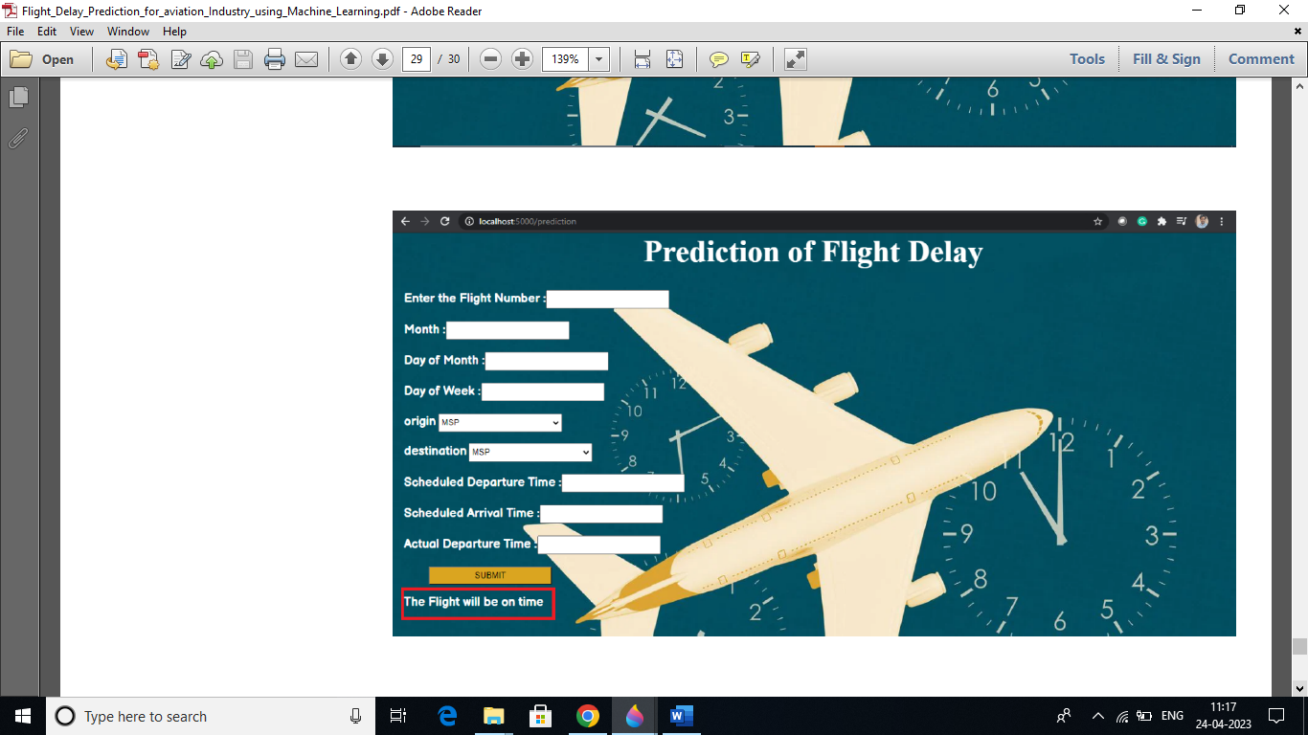

**Disadvantages**

**Flight delays not only irritate air passengers and disrupt their schedules but also cause a decrease in efficiency, an increase in capital costs, reallocation of flight crews and aircraft, and additional crew expenses**

**Application**

**Therefore, predicting flight delays can improve airline operations and passenger satisfaction, which will result in a positive impact on the economy. In this study, the main goal is to compare the performance of machine learning classification algorithms when predicting flight delays.**

**Conclusion**

**In this project, we use flight data, weather, and demand data to predict flight departure**

**delay. Our result shows that the Random Forest method yields the best performance**

**compared to the SVM model. Somehow the SVM model is very time consuming and**

**does not necessarily produce better results. In the end, our model correctly predicts**

**91% of the non-delayed flights. However, the delayed flights are only correctly**

**predicted 41% of time. As a result, there can be additional features related to the causes of flight delay that are not yet discovered using our existing data sources.**

**In the second part of the project, we can see that it is possible to predict flight delay patterns from just the volume of concurrently published tweets, and their sentiment and objectivity.**

**This is not unreasonable; people tend to post about airport delays on Twitter; it stands to reason that these posts would become more frequent, and more profoundly emotional, as the delays get worse. Without more data, we cannot make a robust model and find out the role of related factors and chance on these results.**

**However, as a proof of concept, there is potential for these results. It may be possible to routinely use tweets to ascertain an understanding of concurrent airline delays and traffic patterns, which could be useful in a variety of circumstances.**

**Future Scope**

**Scope of this project is very much confined to flight and weather data of United States, but we can include more countries like China, India, and Russia. Expanding the scope of this project, we can also add the flight data from international flights and not just restrict our self to the domestic flights.**

**Appendix**

**Patients with acute appendicitis may not be transported by aircraft. The main reason is the risk of perforation and septic shock.**